ECA5604- 5g/6g communication
Slot A
M.Pregna
192412350

Experiment 7: Analog Beamforming Analysis Using MATLAB
AIM: To analyze the performance of analog beamforming by studying beamforming gain, beam width,and main lobe direction using MATLAB.
Objective 1: To analyze the beamforming gain achieved by varying the number of antenna elements in an analog beamforming system using MATLAB.
code:
clc;
clear;
close all;
antennas = [2 4 8 16 32]; % Number of Antenna Elements
gain = 10*log10(antennas); % Beamforming Gain (dB)
figure
bar(antennas, gain)
grid on
xlabel('Number of Antenna Elements')
ylabel('Beamforming Gain (dB)')
title('Beamforming Gain for Different Antenna Array Sizes')
output:
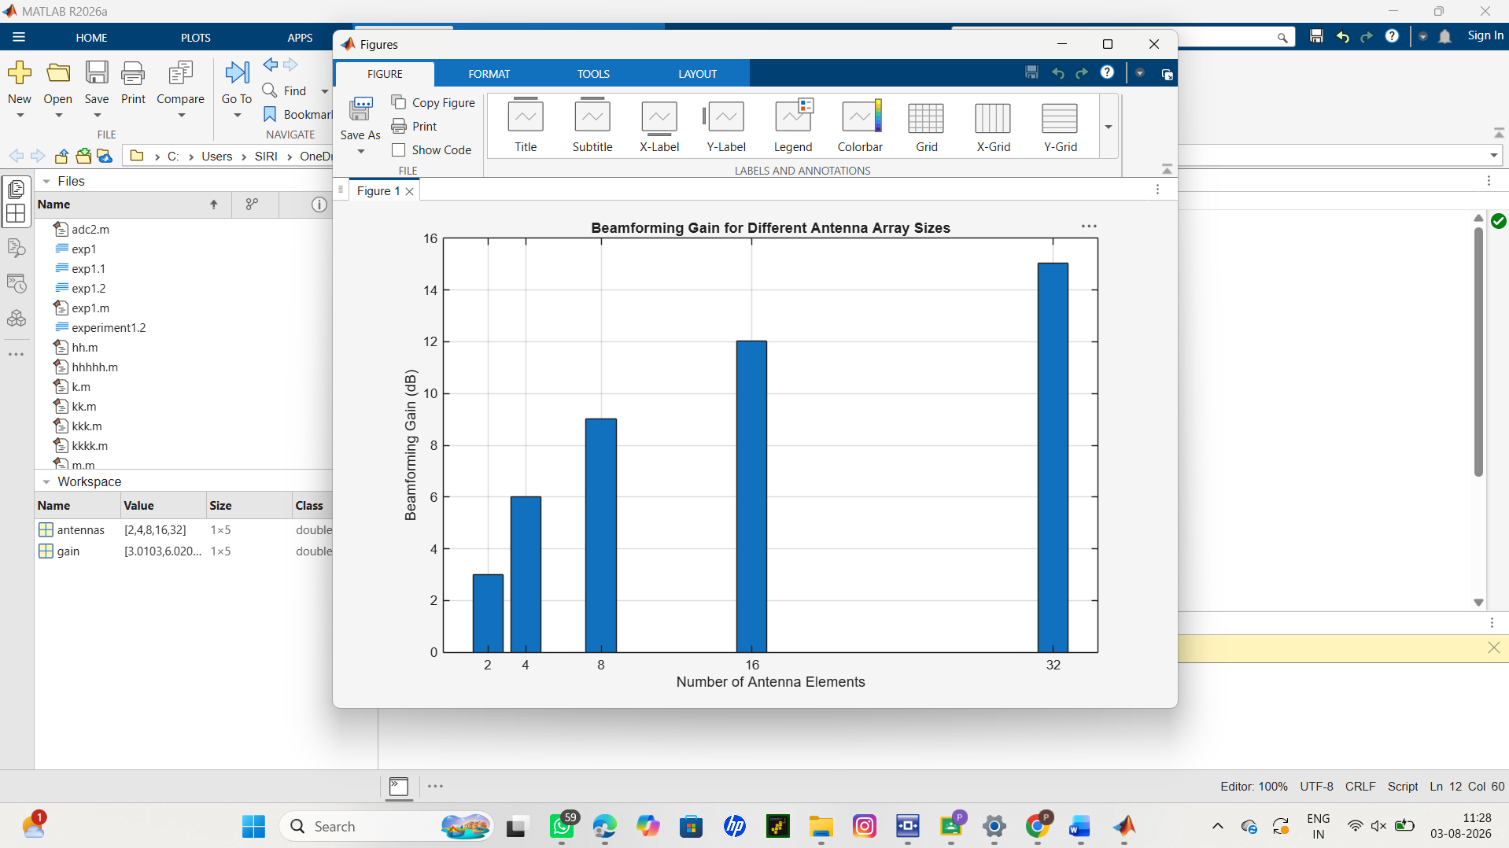
Result:
• Bar graph showing beamforming gain for different antenna array sizes.
Objective 2:
Analyze the beam width corresponding to different antenna array sizes using MATLAB. Observe
how increasing the number of antenna elements results in a narrower beam, thereby improving
spatial resolution.
Code:
clc;
clear;
close all;
antennas = [2 4 8 16 32]; % Number of Antenna Elements
beamwidth = [90 45 22.5 11.25 5.625]; % Beam Width (degrees)
figure
plot(antennas, beamwidth,'o-','LineWidth',2)
grid on
xlabel('Number of Antenna Elements')
ylabel('Beam Width (Degrees)')
title('Beam Width for Different Antenna Array Sizes')output:
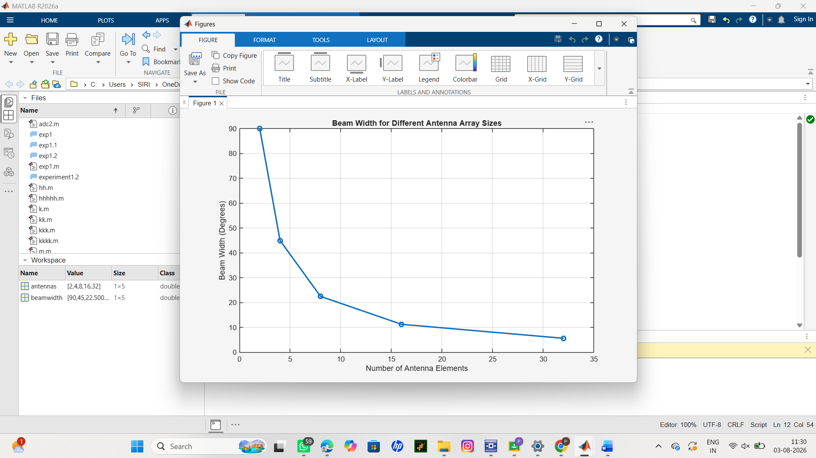
Result:
Line graph showing beam width versus antenna array size.resource usage.
Objective 3:
Simulate beam steering by varying the steering angle of the antenna array using MATLAB.
Observe the change in the main lobe direction and understand how analog beamforming directs
energy toward the intended user.
Code:
clc;
clear;
close all;
theta = [-60 -30 0 30 60]; % Main Lobe Direction (degrees)
gain = [1 1 1 1 1]; % Constant normalized gain
figure
polarplot(deg2rad(theta), gain, 'o', 'LineWidth', 2)
title('Main Lobe Direction in Analog Beamforming')
output:
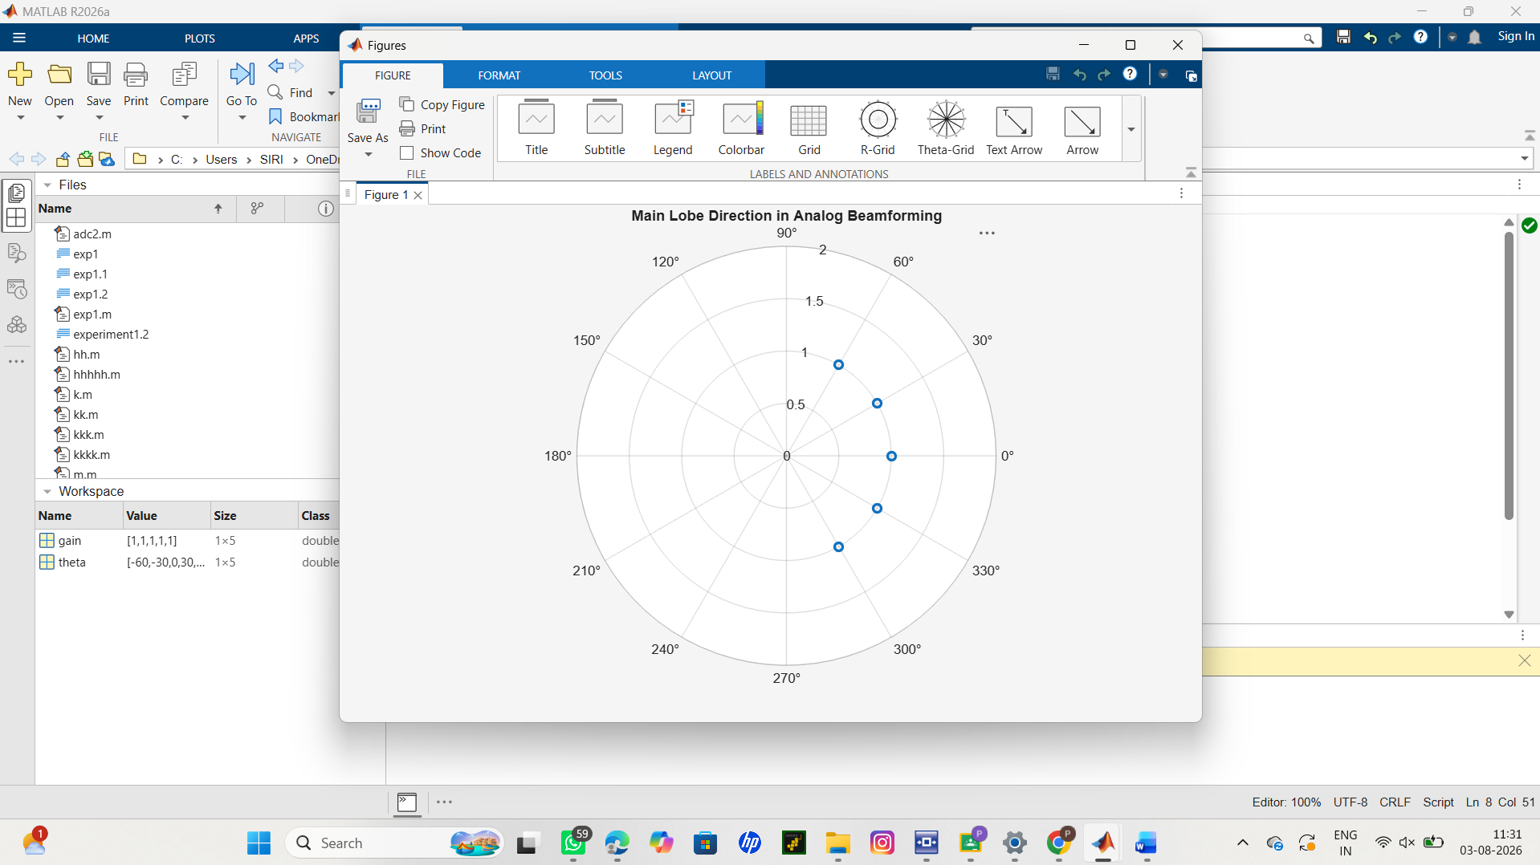
Result:
The MATLAB analysis successfully demonstrated the characteristics of analog beamforming. The
results showed that increasing the number of antenna elements improves beamforming gain and
reduces beam width, while phase adjustment enables the main lobe to be steered toward different
directions.slots are assigned to users while excess users are blocked due to resource constraints.

